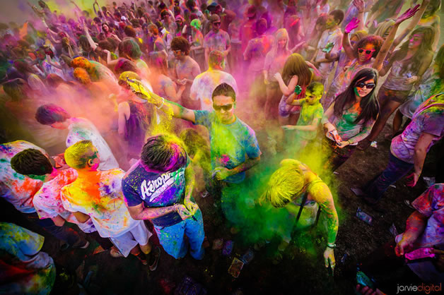

**Holi is one of the major festivals of Hindus. It is celebrated in many parts of India, but especially in the north of India. The festival is celebrated for two to three days. People pour colored water on each other and cook many types of sweets and other food. Holi is celebrated in spring season because it is welcoming spring. They believe spring is full of colours so they throw coloured water on each other..**